2.6 I can check that my web pages meet needs using IT tools and making corrections as necessary

When creating the text for my website I created a draft in Microsoft Word and used the spelling and grammar tool to check that there were no proofing errors that needed to be corrected, correcting any issues that were found.

When checking the code for my website I used an online tool provided by W3; <https://validator.w3.org/> to check my html by copying and pasting the html into the checker;

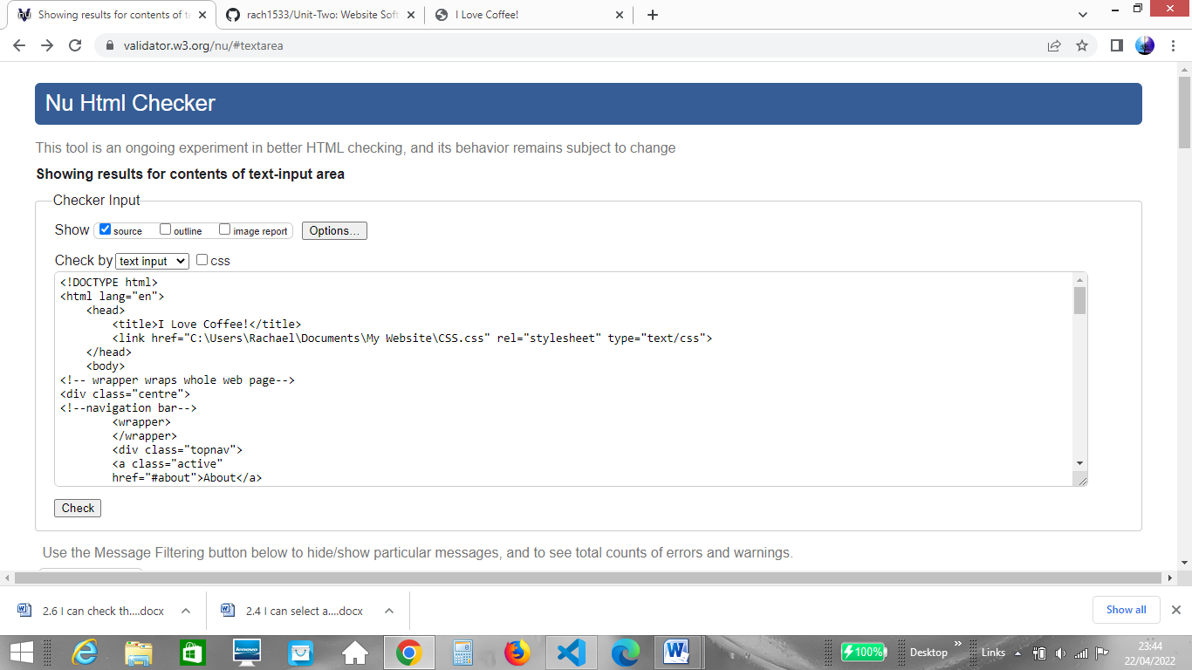

The checker found issues with my code that needed to be corrected, for example unclosed elements and an image uploaded without an alt tag.